

**Placement Empowerment Program**

***Cloud Computing and DevOps Centre***

Automate File Copying with a Script

Create a script to copy files from one folder to another automatically.

Name: ASWIN J

Department: ADS



# Introduction

In many workflows, the need to transfer files from one directory to another arises frequently. Automating this process can save time and reduce the risk of human error..

# Objectives

**1.Automate File Transfer**: Implement a Python script that copies files from a source directory to a destination directory.

**2.Verify Outcomes**: Ensure that the files are copied successfully and check for any errors during the transfer.

# Step-by-Step Overview

## **Step 1 :**

Need two folders for Source and Destination in which we are going Copy files from source to destination

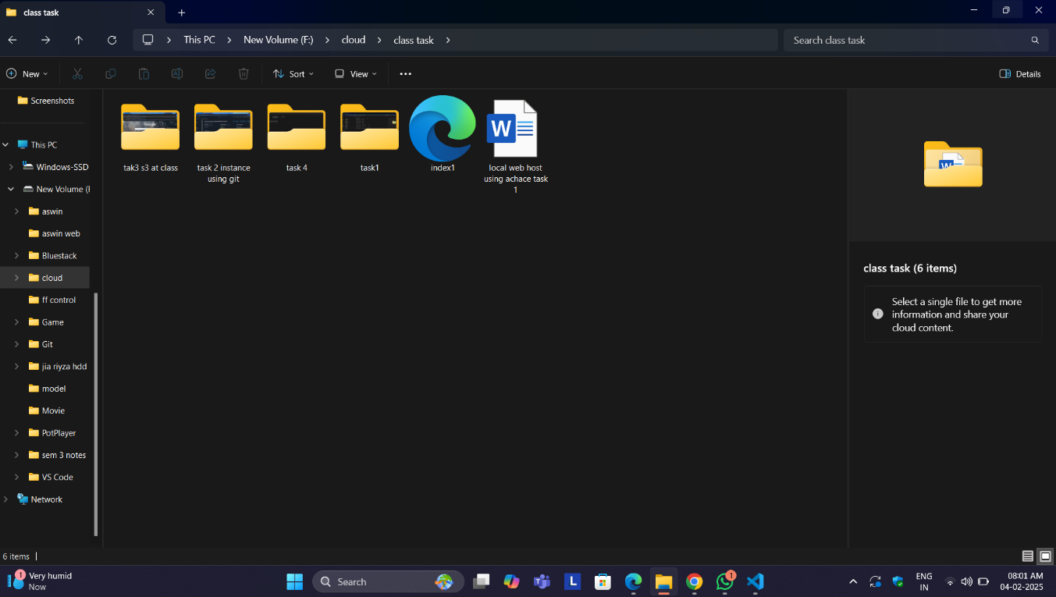

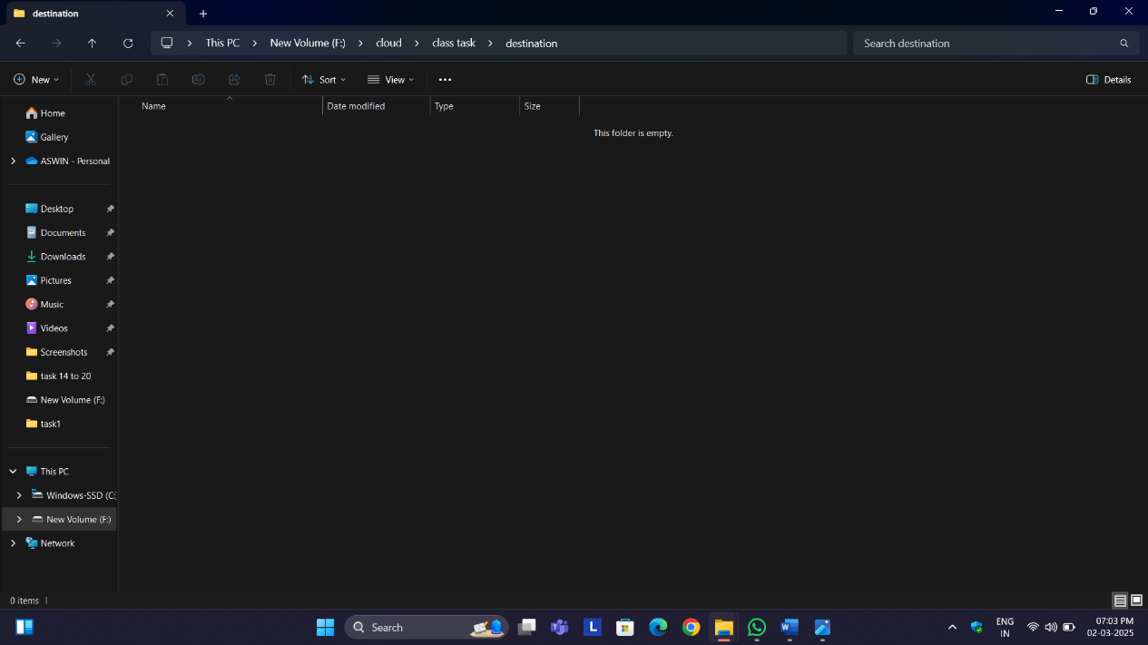

## Step 3

Open the visual studio cod and type the code and fill the source folder ‘s path in set source and fill destination folder’s path in set destination

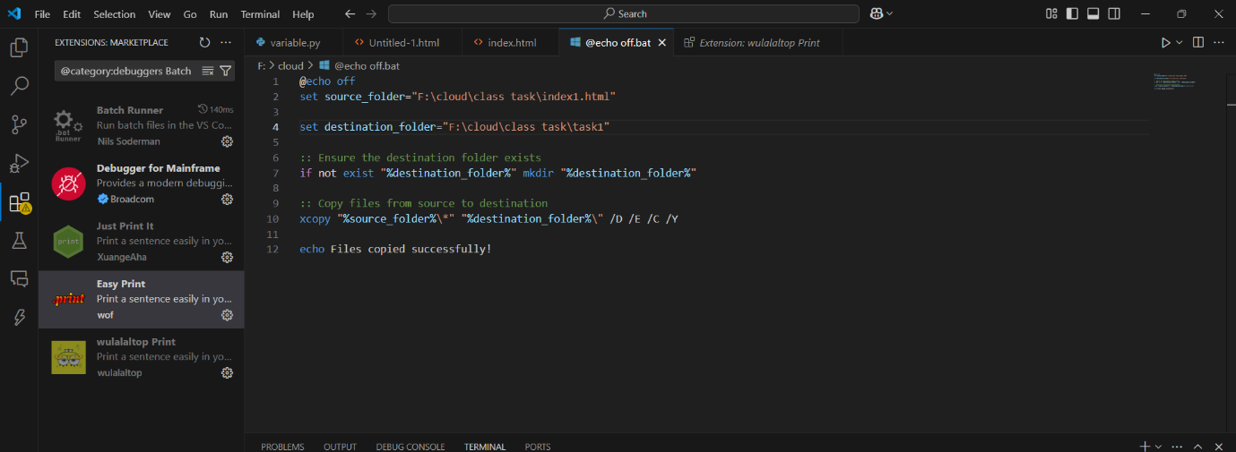

put your source and destination path

## Step 4

Then save the file in desktop with .bat extension (eg : index.bat) so the file looks like this

## Step 5

Run this code in vs code

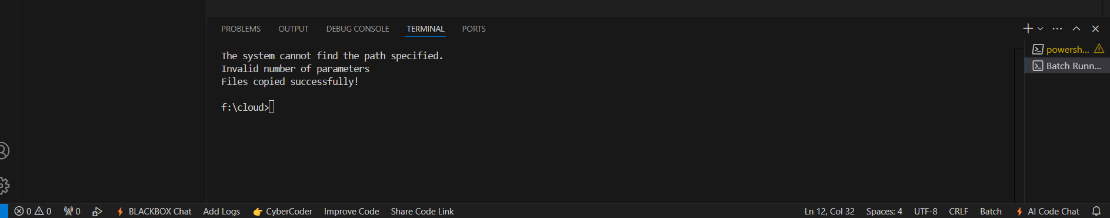

## Step 6 :

After this our file has been successfully transferred from our source to destination

